**Start ElasticSearch Cluster:**

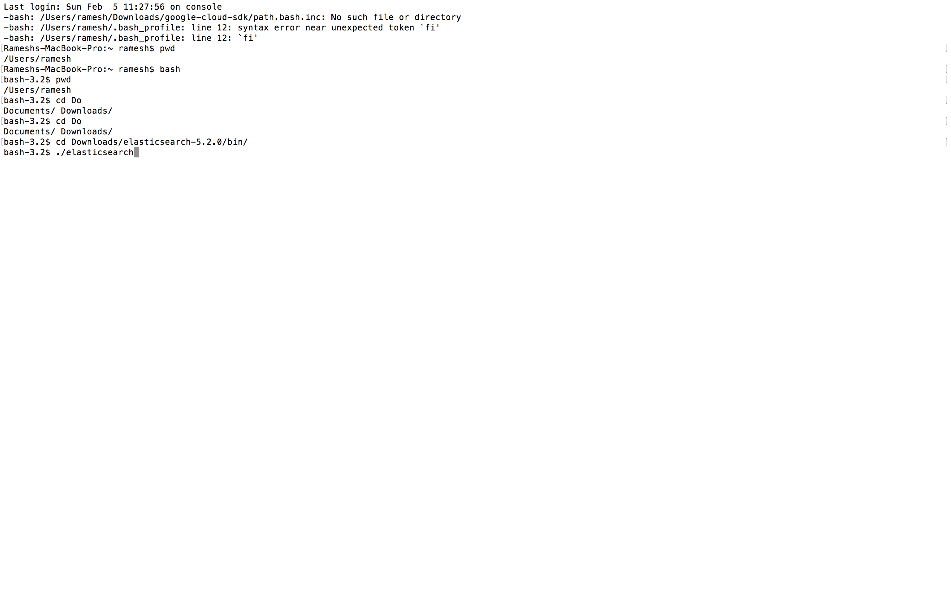

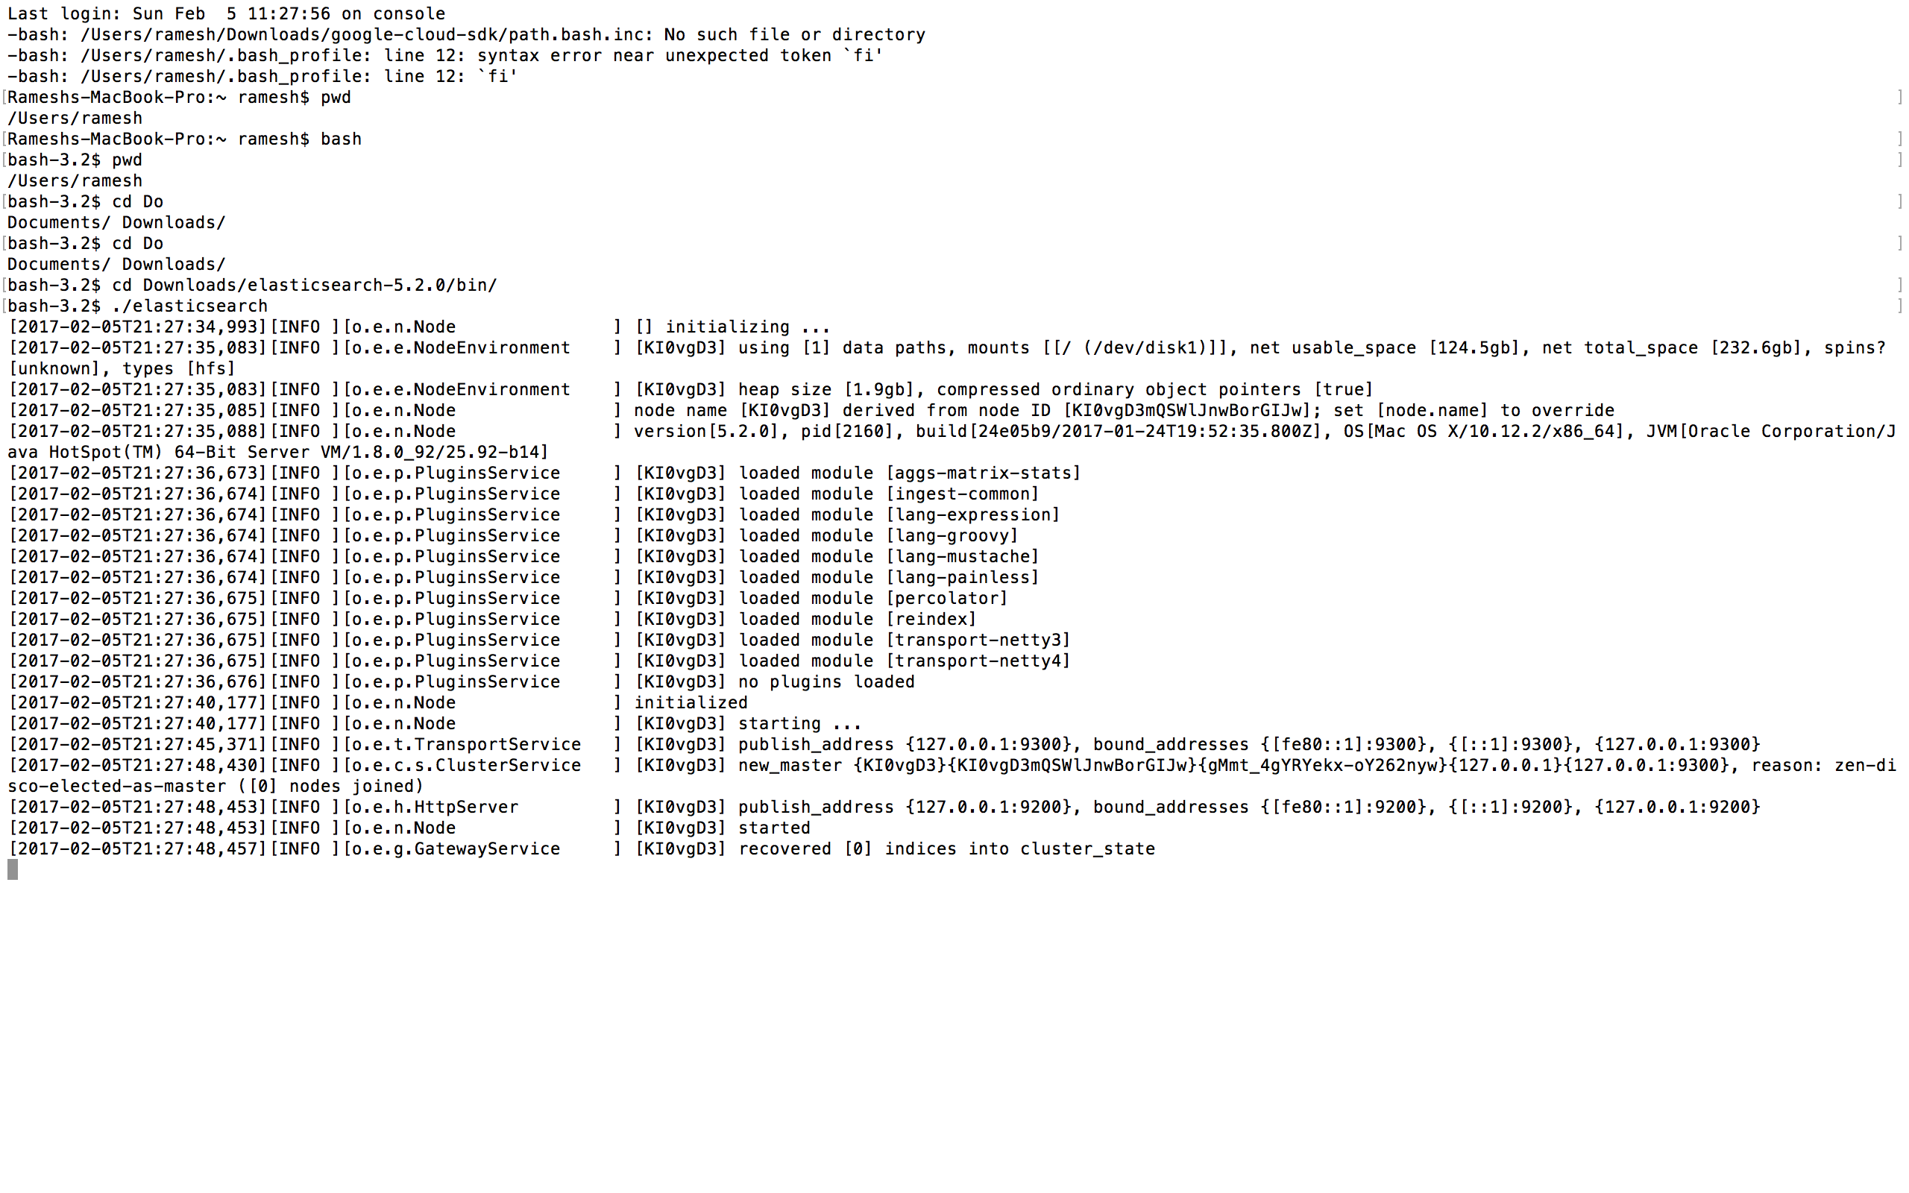

**Check ElasticSearch Cluster Health:**

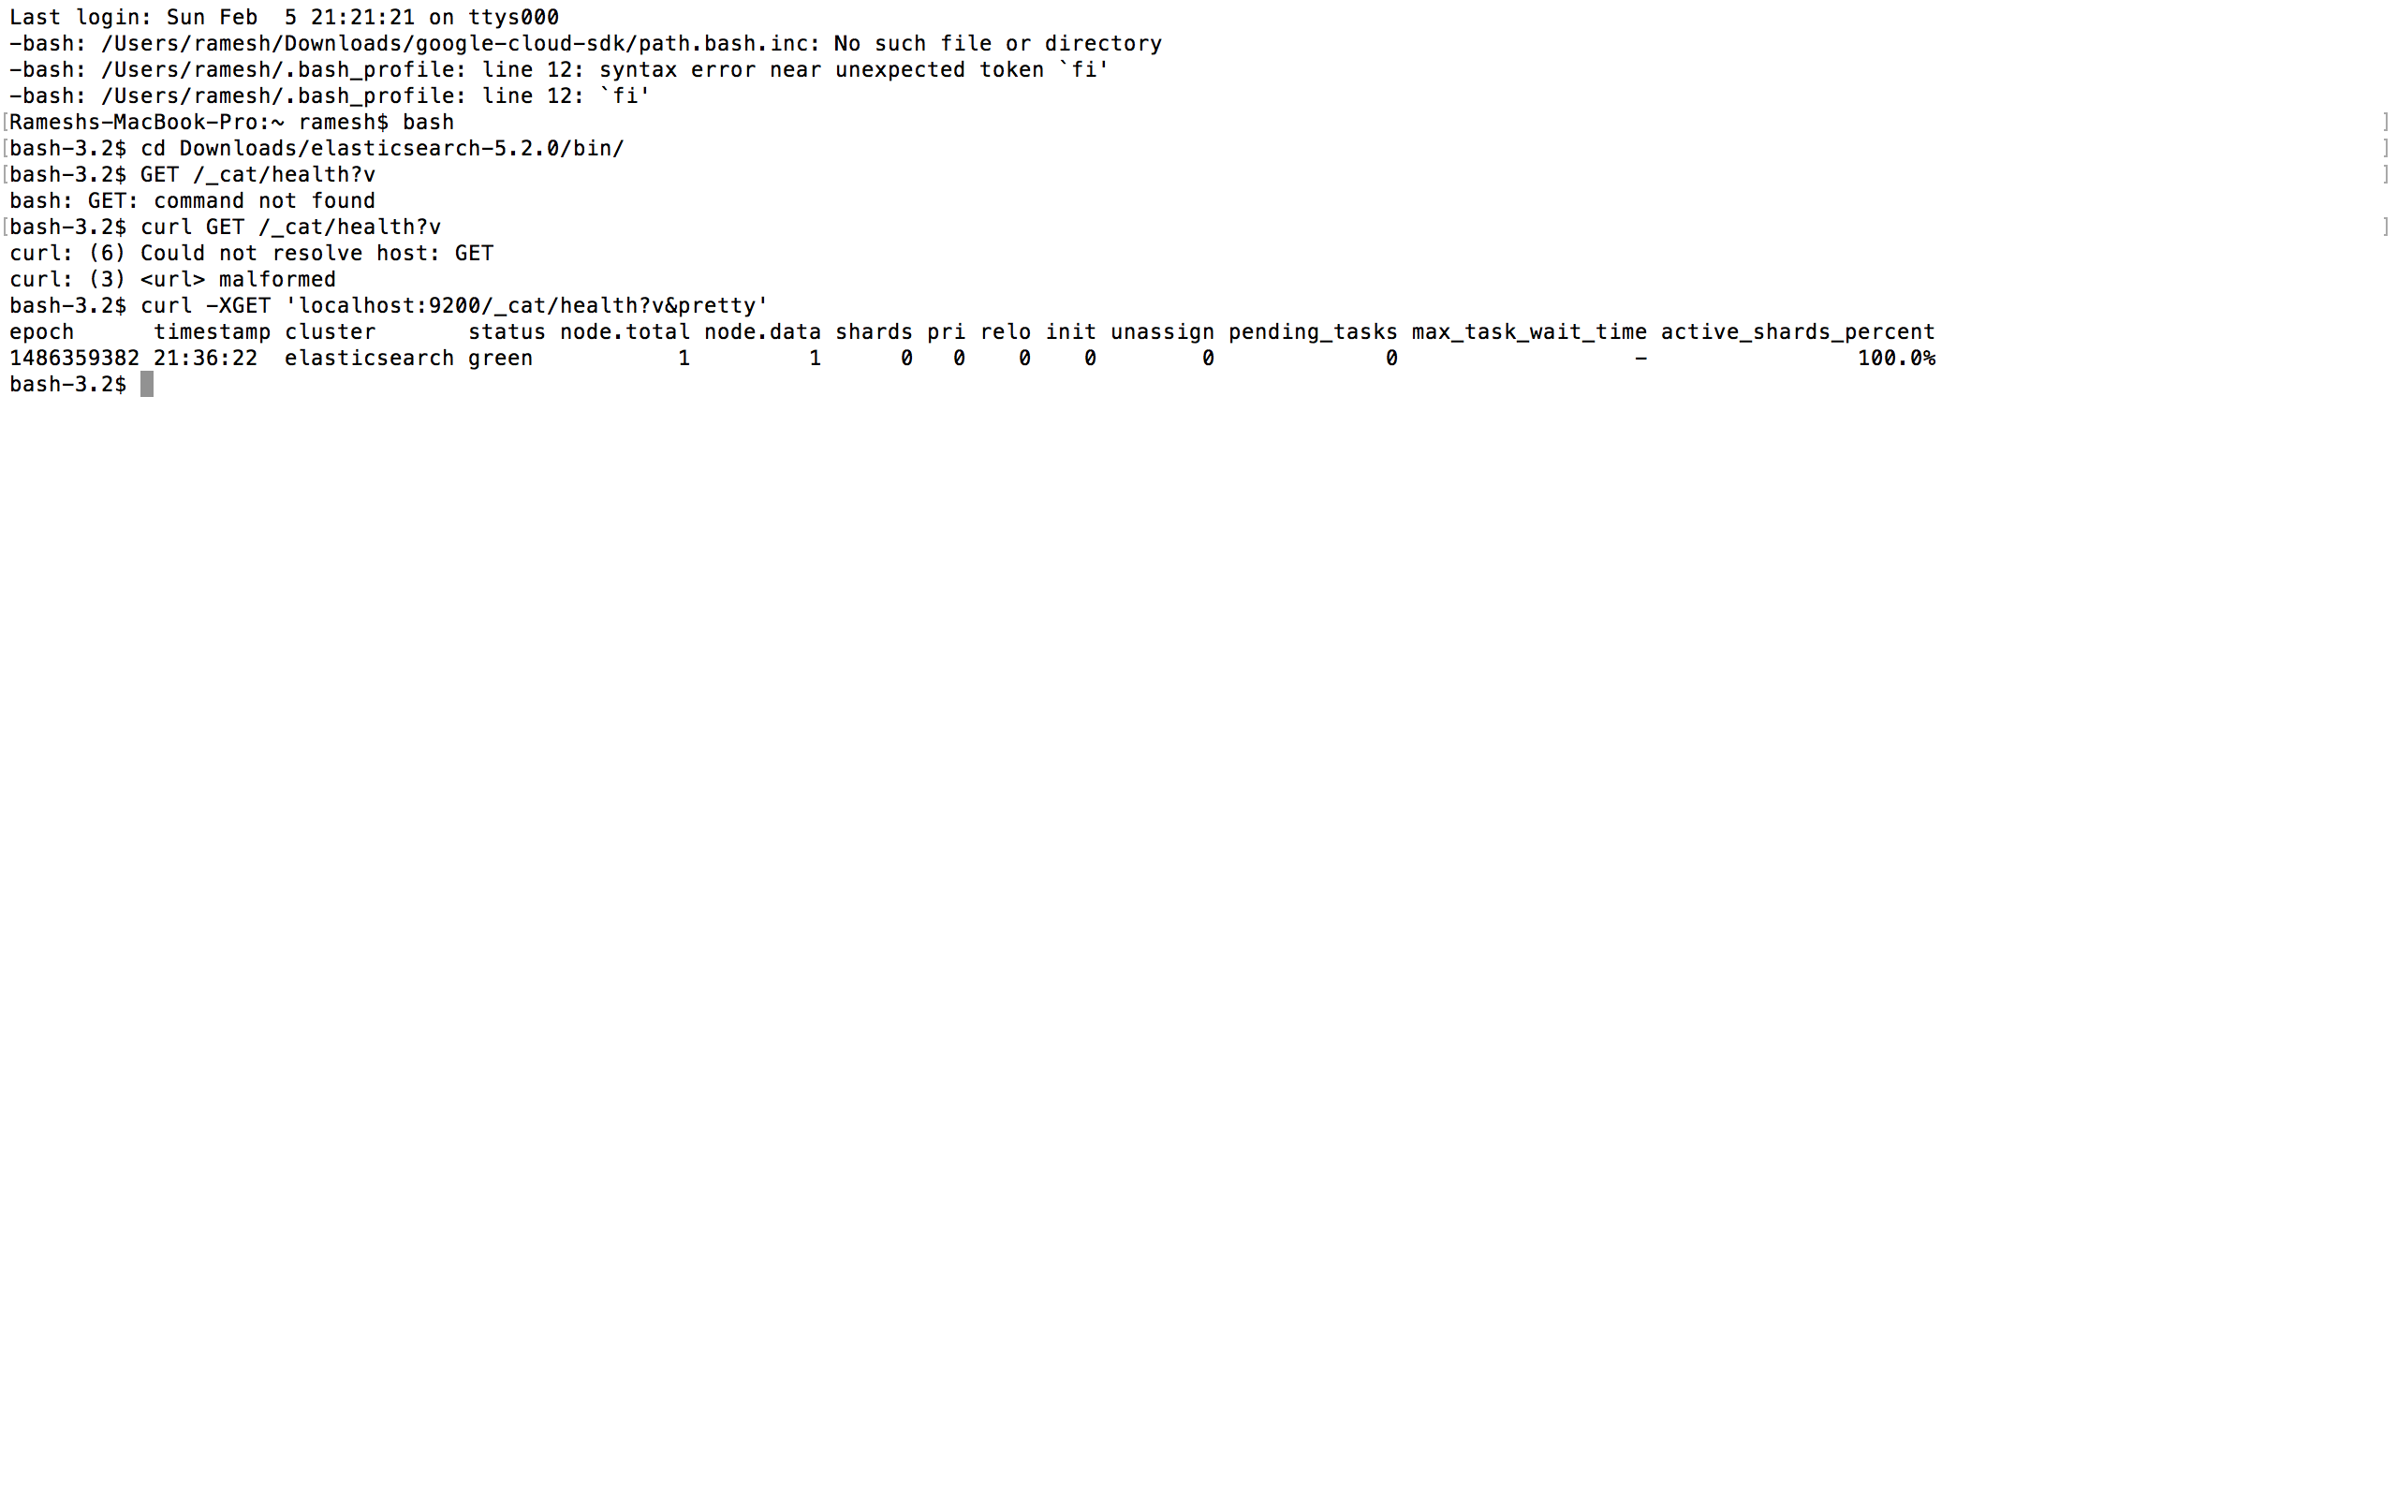

**Create an Index named “Customer” on cluster:**

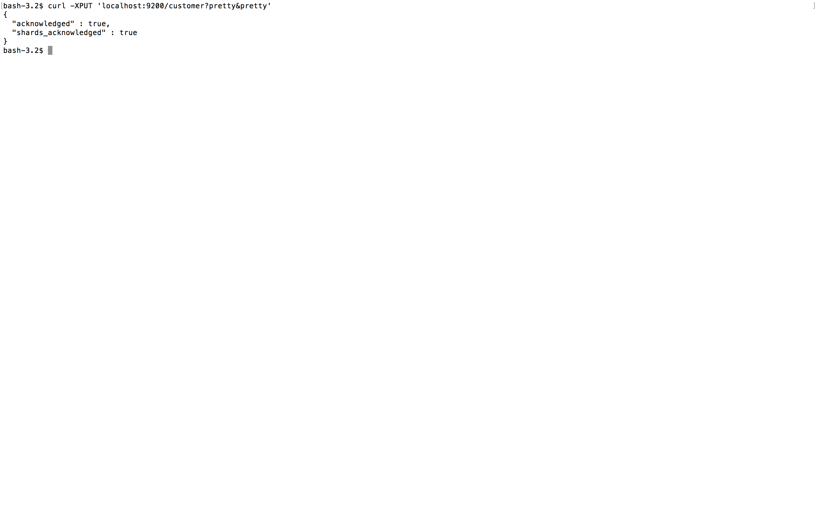

**Get All the indices in cluster:**

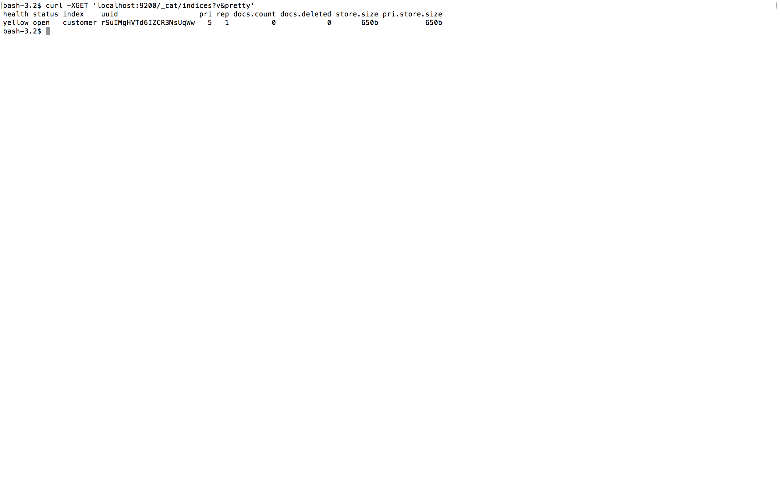

**Index a document of “external” type in “Customer” index:**

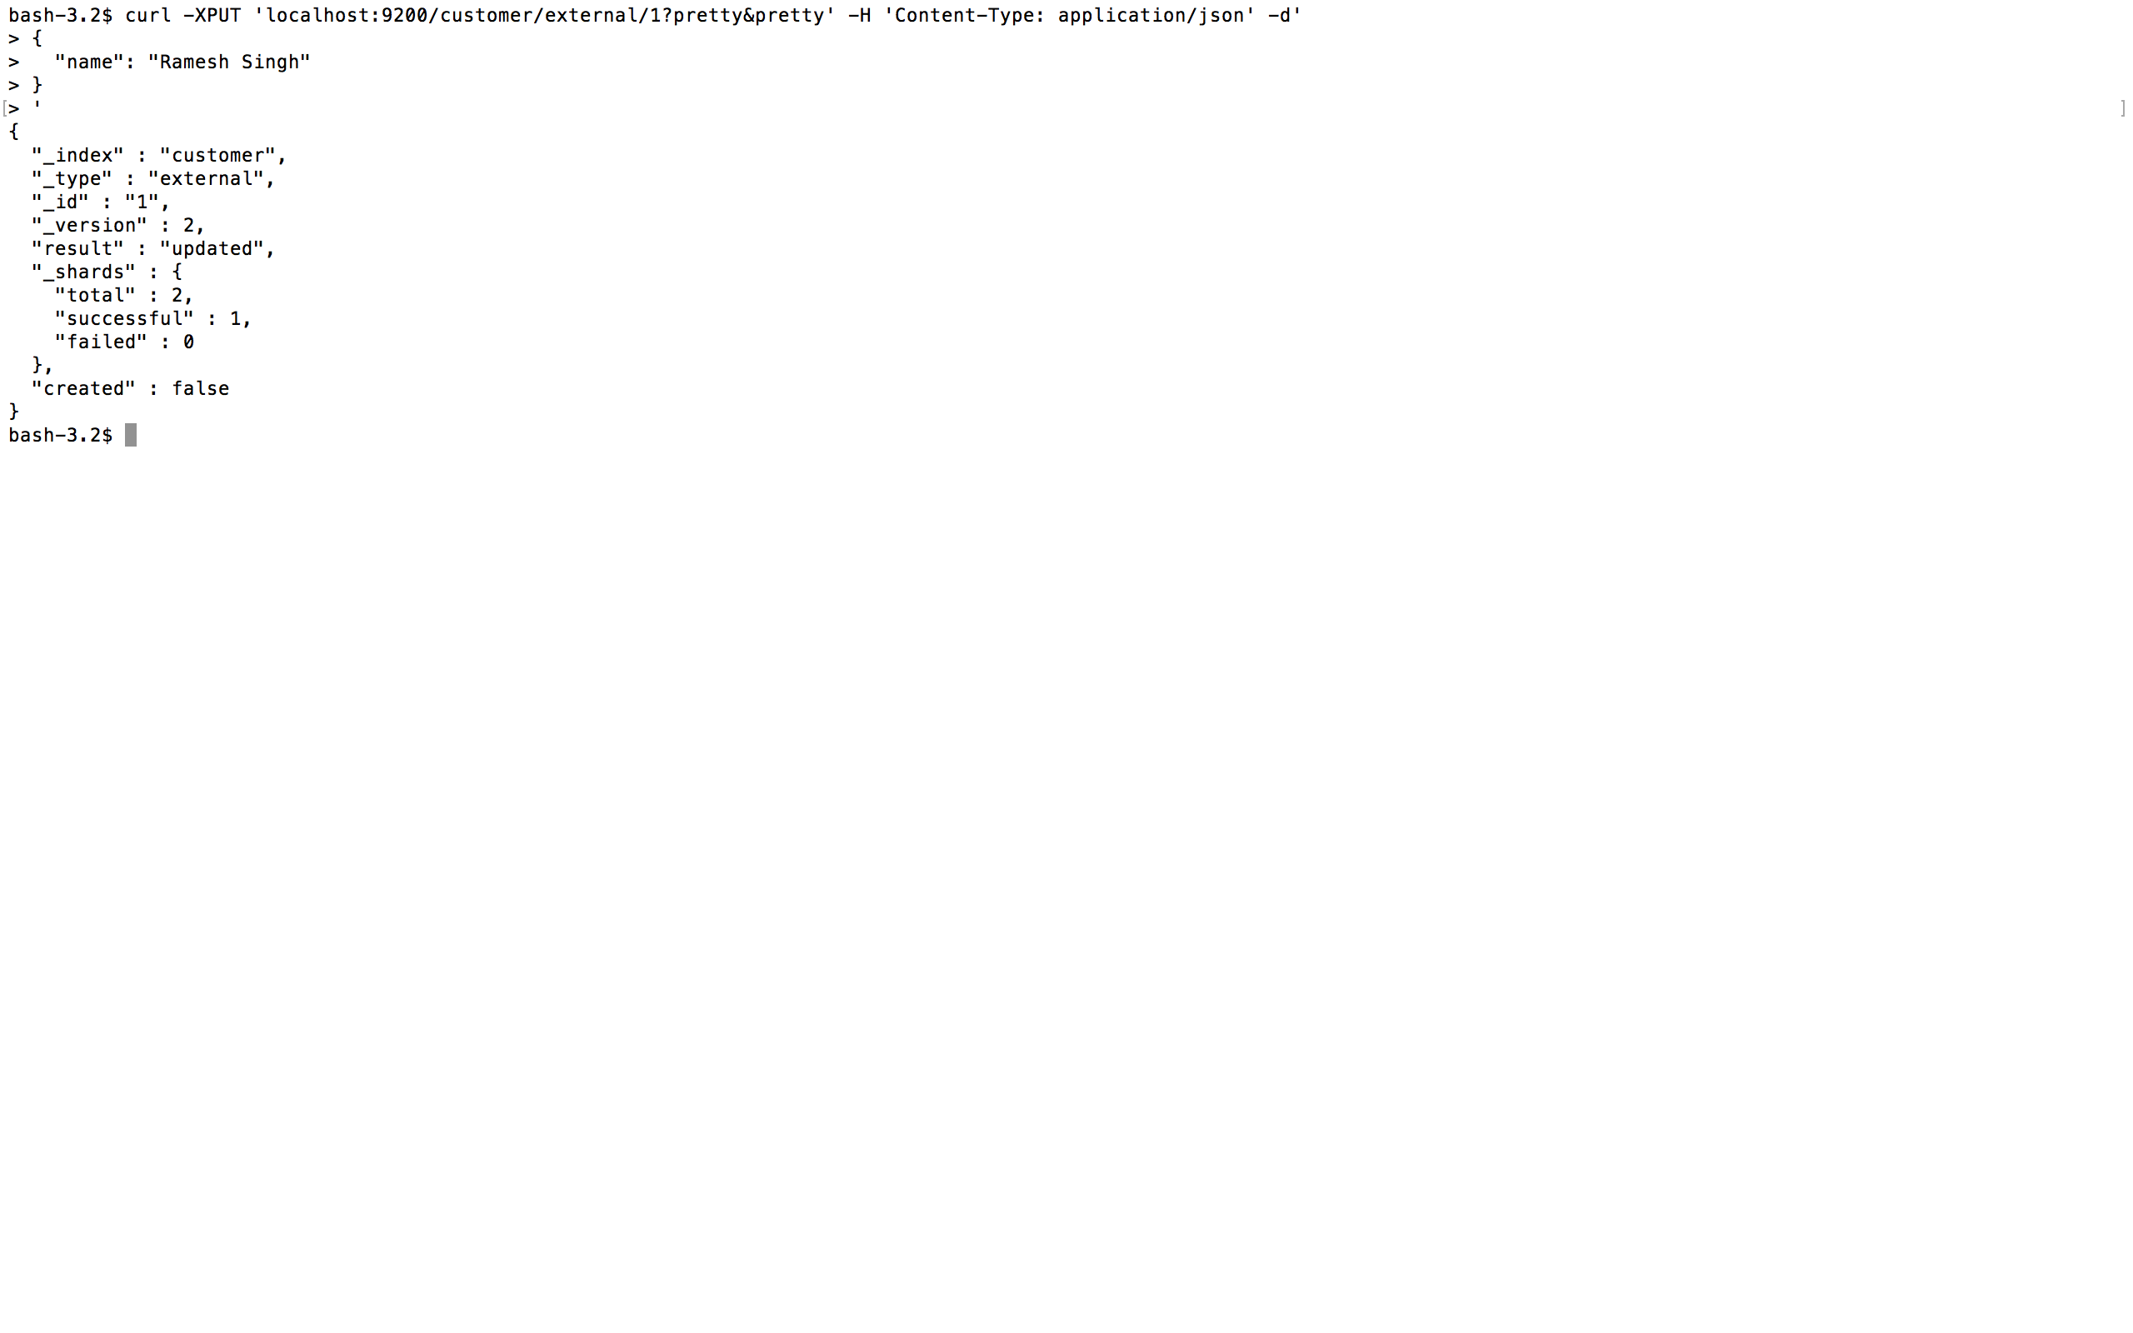

**Retrieve a document of “external” type from “Customer” index where ID = 1:**

